5th Grade Art Projects
(these are suggested months in which to conduct these lessons, based on the type of project it is. Teachers should be consulted to ensure that these are the projects they want in their classrooms. One teacher from each grade can be the facilitator of the conversation with their cohorts)
October: Britto Brazilian Art
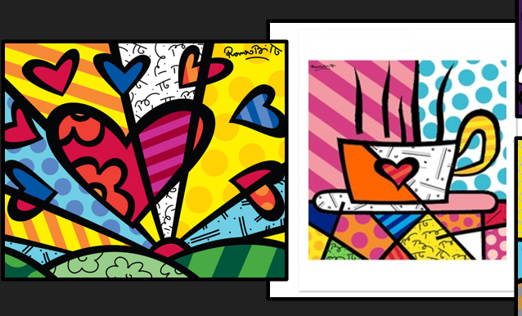
November: Watercolor Trees by Anton Pavlenko
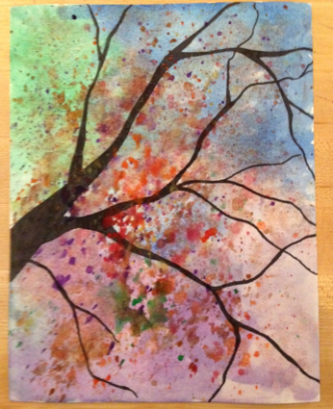
December: Winter Fox Acrylic Using Texture (on canvas?)
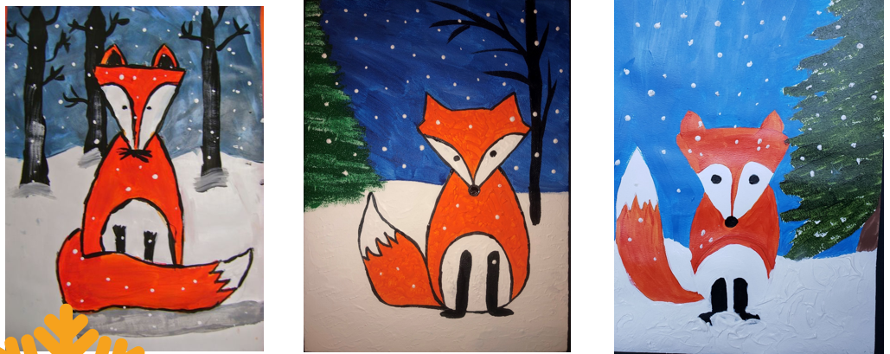
January: Metal Embossing
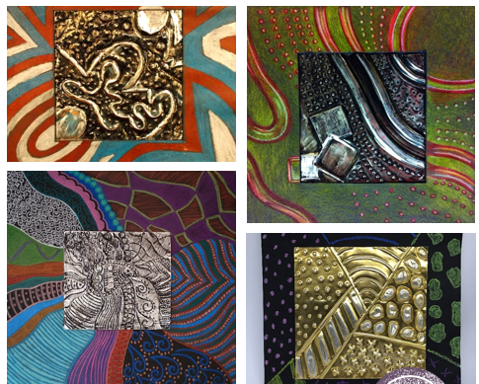
February: OP Art
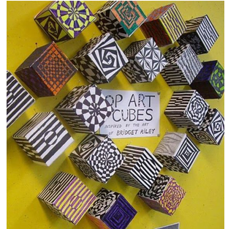
March: Clay with melted glass (the real 5th grade project. I am considering moving this to 4th grade from now on)
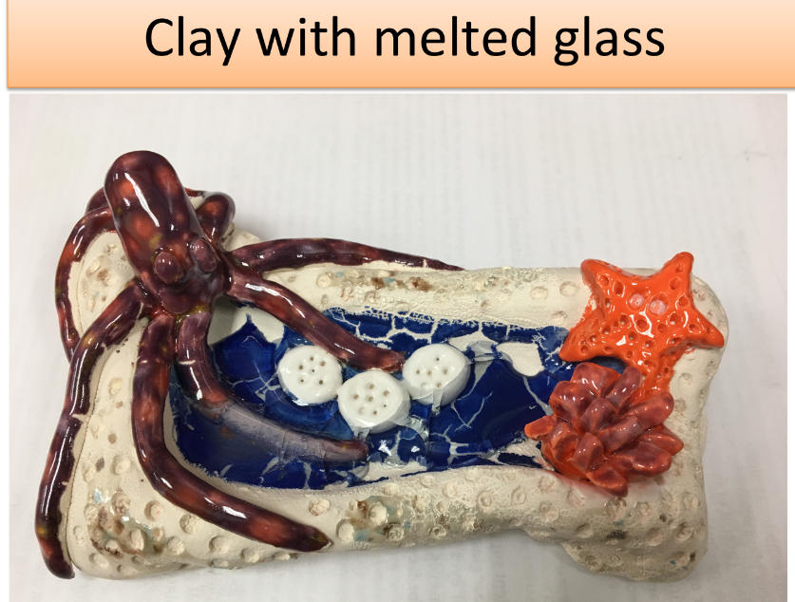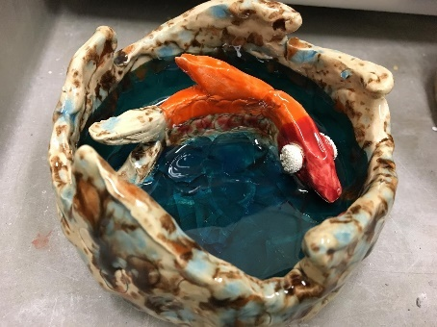

April: Didier Triglia Cannettes (Recycled soda can art)
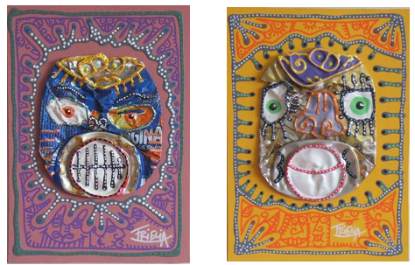
May:
Or Fused Glass Mosaics
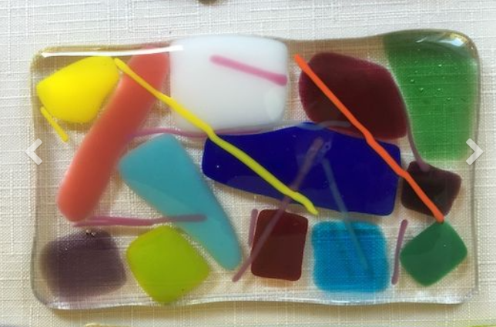

Additional Art Projects:
Water color Ocean w/Oragami Sailboat
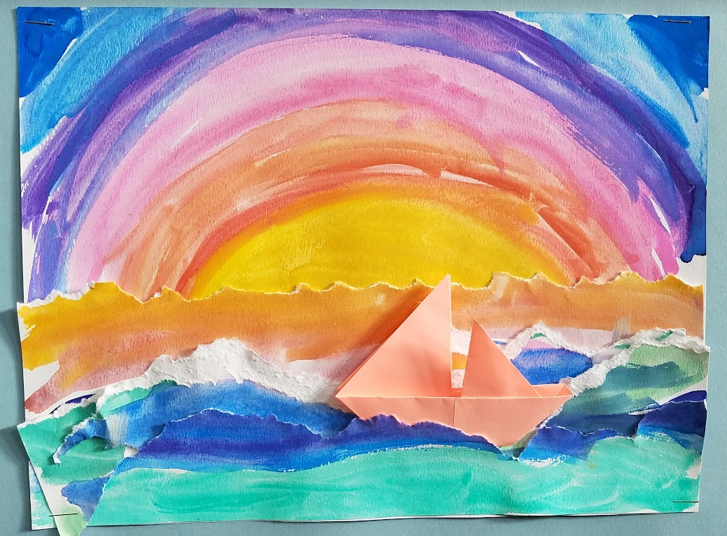

Self Portrait Micrography
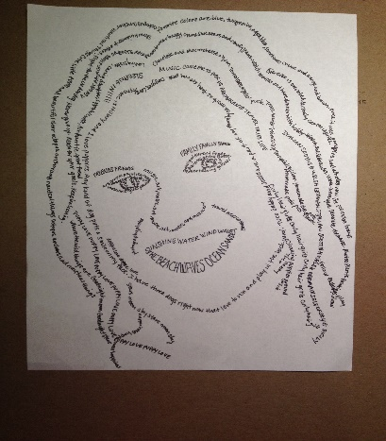
Mosaic Tile
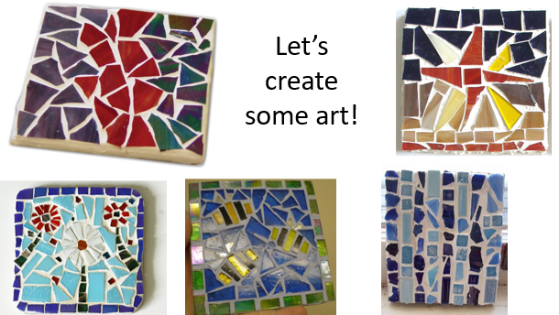

Felt Flowers (great May Relative Day Gift) Sewing and Cutting project.
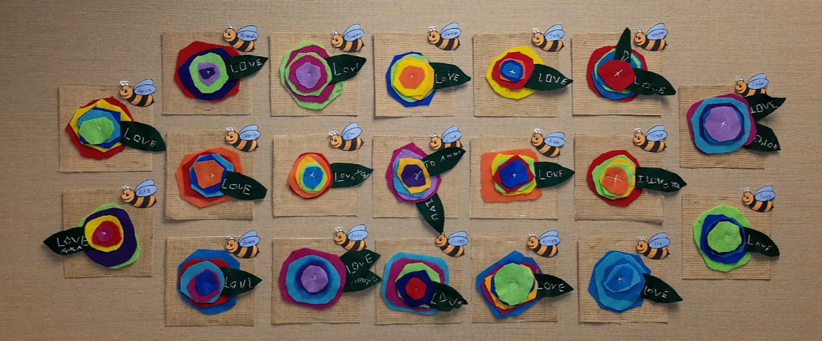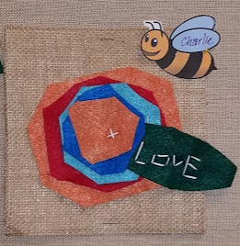
Pioneer Quilt Art
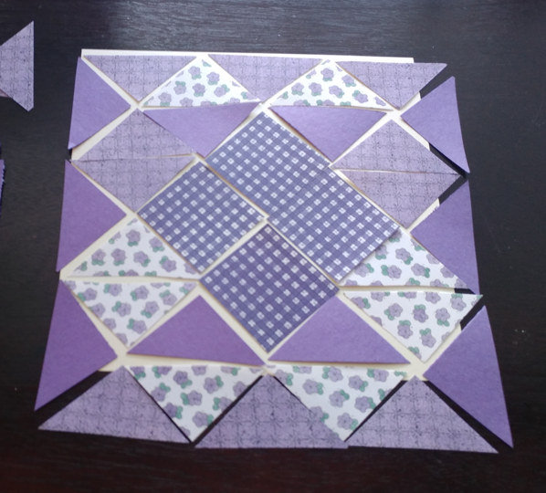
Colonial Braided Rag Rug (wall art)
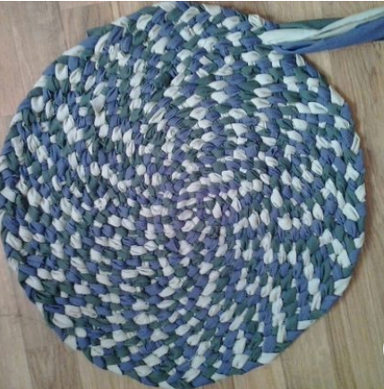

Elongated Necks by Amedeo Modigliani
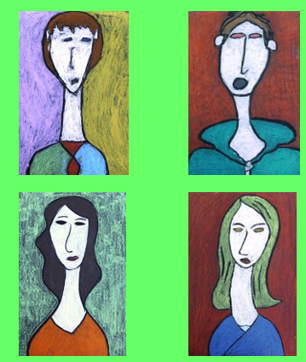
Underwater Perspective
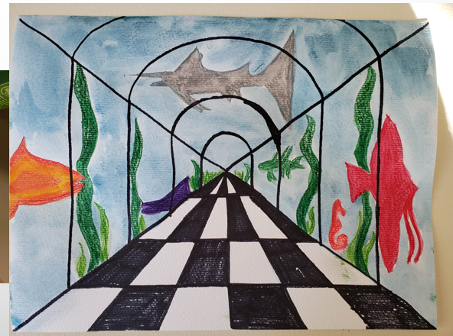
Owls
